Module 12 – Location Graph

Exploratory Data Analysis

*In this section, you should perform some data analysis on the data provided to you. Please format your findings in a visually pleasing way and please be sure to include these cuts:*

Model Formulation

*Try to write the formulation of the model into here prior to implementing it in your Excel model. Be explicit with the definition of the decision variables, objective function, and constraints. Hint: Linking constraints aren’t needed since we are using Nonlinear GRG but refer to the associated PowerPoint in your data if you need help.*

Decision Variables:

X1 = Location of the new Distribution Center with respect to the X axis

Y1 = Location of the new Distribution Center with respect to the Y axis

Objective Function:

MIN SQRT (((43.56-Xi)^2)+(-91.61-Yi)^2)) + SQRT (((34.95-Xi)^2)+(-110.05-Yi)^2)) + SQRT (((41.52-Xi)^2)+(-117.4-Yi)^2)) + SQRT (((43.71-Xi)^2)+(-100.08-Yi)^2)) + SQRT (((40.28-Xi)^2)+(-103.16-Yi)^2)) + SQRT (((32.86-Xi)^2)+(-108.24-Yi)^2)) + SQRT (((38.57-Xi)^2)+(-86.51-Yi)^2)) + SQRT (((44.93-Xi)^2)+(-92.8-Yi)^2))

No Constraints

Model Optimized for Distance Reduction from DC to Store

*Implement your formulation into Excel and be sure to make it neat. This section should include:*

*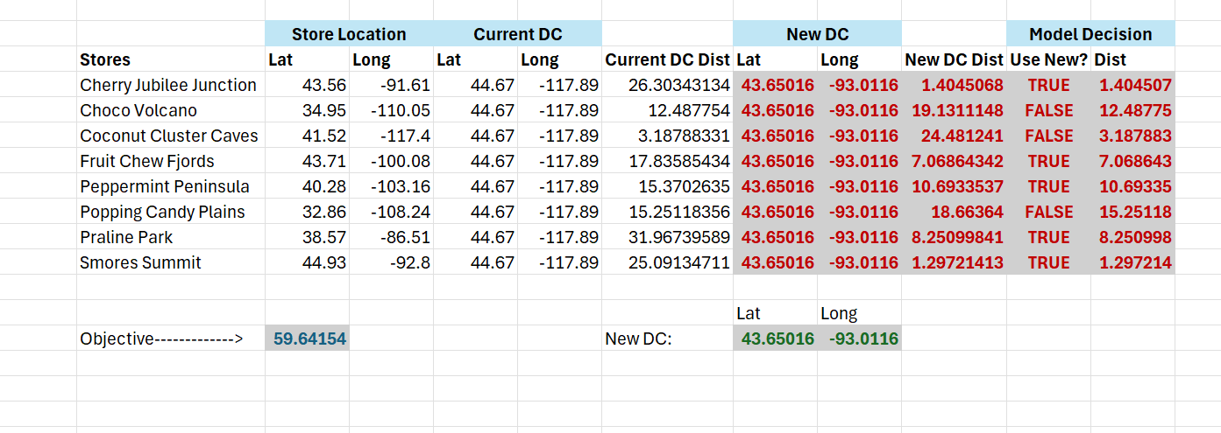*

This model recommends the exact location for a new Distribution Center for the Fish and Murr Candy Shop based on the locations of our current stores with intention to place a new distribution center closer to our stores.

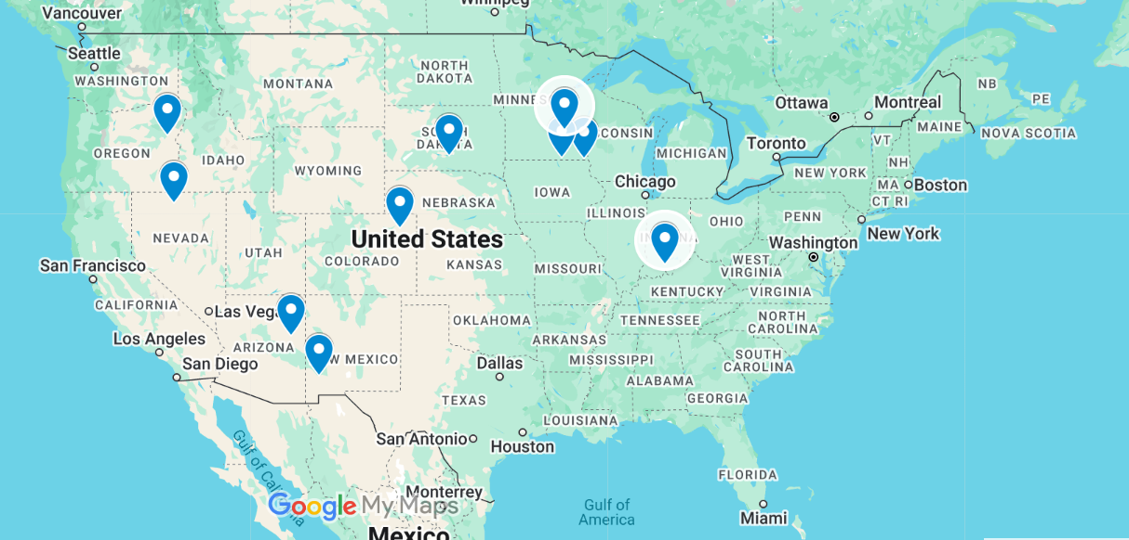

Model with Stipulation

*Please copy the tab of your original model before continuing with the next part to avoid messing up your original solution.*

*You should notice that while distance is minimized between each store and each DC, there is a discrepancy between how much demand is serviced between each DC (i.e. one DC may service a lot more demand than others). Please:*

1. *Choose one:*
   1. *Implement a change that picks a location for the new DC to distance AND load. You can do this by multiplying distance by demand if a store is serviced by a particular DC.*
   2. *Instead of just summing the distance, also add the difference between demand serviced between each DC (i.e. if the old DC serves stores with 8000 total demand and the new DC does 3000 then the difference would be 5000). Be sure to not remove the sum of distance too, it should be both. You may want to add weights and such but not necessary*

*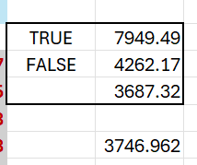*

1. *Provide a text explanation on what your model is recommending now with this change.*

The Model is recommending a better optimization for the distance and demand for the new DC. The new DC will slightly favor cities with more demand making it more optimal. The objective solution is more optimal.

1. *Explain the changes to your Solver/Model.*

None